**P-Plinth**

Image:

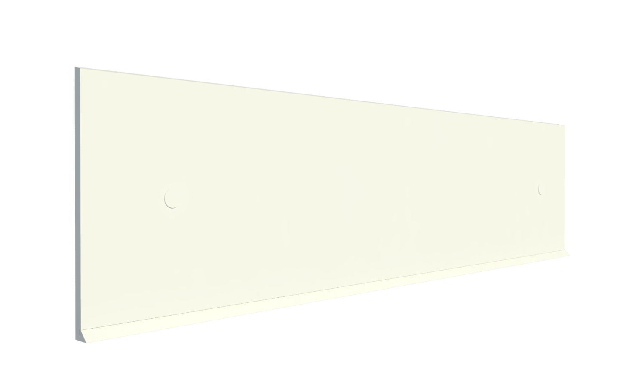

Description: High-performance polymer protection plinth system designed for protecting the lower part of walls.

Features and Benefits:

* High-Performance protection technology
* Available in various heights.
* Hygienic and easy to clean and maintain.
* Tested to BS EN 1186-2:2002 and BS EN 1186-3:2002 for food contact.
* Suitable for temperatures between -100°C to +80°C
* High resistance against acids, alkali, and solvents.
* Typically 40% recycled polymer content.
* 100% recyclable at end-of-life.
* Tested to BS EN ISO 4892-2:2014 for UV Resistance – Zero Discoloration
* Internal and external corner pieces also available.

Technical Specification:

|  |  |
| --- | --- |
| **Parameter** | **Measurement** |
| Standard Length | 2000mm |
| Height | 1000mm, 500mm, 300mm, 210mm and 150mm |
| Base thickness (+/- 1mm) | 40mm |
| Plinth thickness (+/-1mm) | 20mm |
| Density | 0.91g/cm3 |
| Breaking elongation | 70% |
| Impact resistance | 7 |
| Shore Hardness | 72 |
| Chemical resistance - acids / alkalis | Excellent |

Colours:

* White RAL 9016





Uniclass 2015: Ss_25_16_94_65 Protective rail systems

Literature: Polybar Product Brochure & Product Datasheets can be found on: [www.polybargroup.com](http://www.polybargroup.com)

Revit files can be found on: [www.polybargroup.com](http://www.polybargroup.com)