**P-*FLEX* Goalpost**

Image:

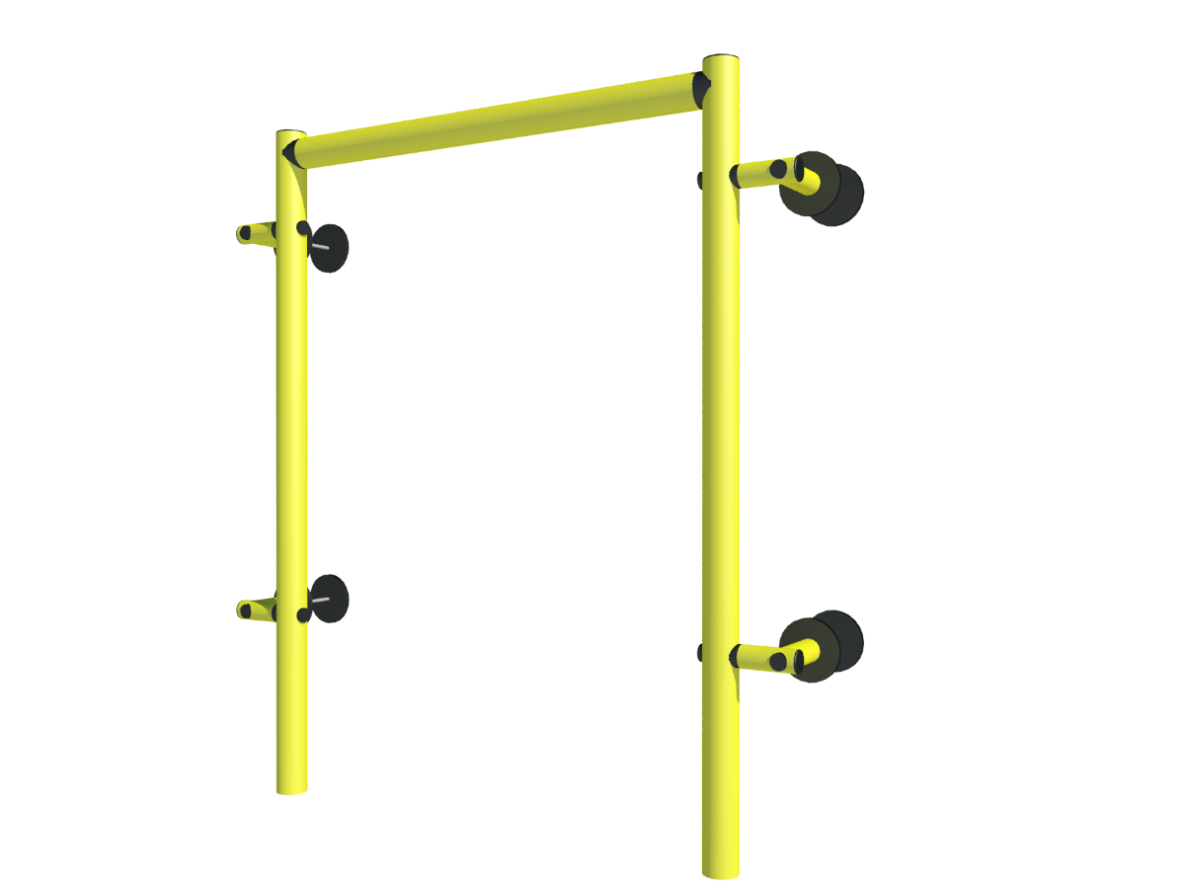

Description: P-*FLEX* Goalpost is a proven door perimeter protection system that features P-*FLEX* technology

Features and Benefits:

* Its unique design provides maximum protection for internal or external door systems.
* P-*FLEX* High-Performance flexible protection technology designed to deflect, and safety absorb impacts.
* Tailored and manufactured to specific door sizes.
* Built-in Reinforcement arms
* Can also be supplied as a height restrictor without reinforcement arms rather than a Goalpost protection system.
* Suitable for horizontal and vertical door openings
* Can be mechanically fixed to a range of substrates including insulated panel systems and concrete walls.
* Unique “Hidden” Steel Threaded Rod anchoring system.
* Hygienic and easy to clean and maintain.
* Tested to BS EN 1186-2:2002 and BS EN 1186-3:2002 for food contact.
* Suitable for temperatures between -100°C to +80°C
* Zero exposed steel or risk of exposed corrosion.
* High resistance against acids, alkali, and solvents.
* Typically 40% recycled polymer content.
* 100% recyclable at end-of-life.
* Tested to BS EN ISO 4892-2:2014 for UV Resistance – Zero Discoloration
* See Polybar product brochure for mechanical and impact resistance performance.

Technical Specification:

|  |  |  |  |  |  |
| --- | --- | --- | --- | --- | --- |
| Dimensions | | | | | |
| Widths (mm) | 2500 | 3000 | 3500 | 4000 | For other measurements consult |
| Heights (mm) | 2500 | 3000 | 3500 | 4000 | For other measurements consult |

Colours:

* Yellow RAL1021– standard
* Black RAL 9004
* Other non-standard colours available – Contact Polybar for further information.

Unique high-performance polymer technology testing:

* Density g/m3 ISO 1183: 0.95
* Yield Stress N/mm2 DIN EN ESE 527: 28
* Elongation yield % DIN EN ISO 527: +8
* Elongation al break %: 300
* Tensile E Modulus MPa DIN EN ISO 527: 850
* Impact strength KJ/m2 DIN EN ISO 179: without break
* Notched Impact Strength KJ/m2 DIN EN ISO 179: 50
* Ball identification hardness N/mm2 DIN EN ISO 2039-1: 45
* Shore Hardness D ISO 868: 66
* Average Thermal Coefficient of elongation K-1 DIN 53752: 1’8. 10-4
* Thermal Conductivity W/m*K DIN 52612: 0.38
* Dielectric Strength KV/mm VDE 0303-21: 44
* Surface resistance Ohm DIN IEC 167: 1014
* Temperature Range °C -100 up to +80
* Physiologically acceptable: yes
* Welding: yes
* Hot Forming: possible

Uniclass 2015: Ss_25_16_94_65 Protective rail systems

Literature: Polybar Product Brochure & Product Datasheets can be found on: [www.polybargroup.com](http://www.polybargroup.com)

Revit files can be found on: [www.polybargroup.com](http://www.polybargroup.com)